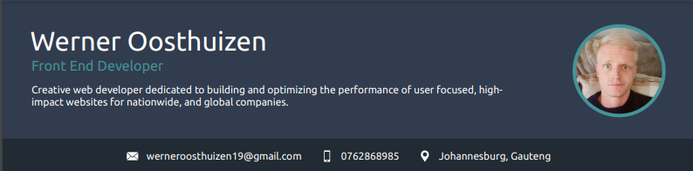

SUMMARY
I am an experienced designer and developer with a diverse skill set across various aspects of web development and digital marketing. With experience working in both agency and corporate environments, I have developed a strong understanding of client needs and how to deliver high-quality projects that meet their specific requirements. I have a proven track record of delivering exceptional work that drives business success.

EXPERIENCE

Osiris Trading, Johannesburg - Web Designer & Developer
11/2014 - 07/2017 - Gaming Industry
- Designed graphics and created website designs for user experience and search engine optimization (SEO)
- Worked on mobile development using Unity 3D for iOS and Android applications Developed affiliate marketing, Google Adwords, PPC campaigns, and social media marketing strategies
- Utilized technical skills including HTML, JavaScript, and SCSS to build and maintain gaming affiliate websites
- Prioritized user experience and usability in website and mobile application designs
- Conducted user research and usability testing to inform design decisions

Venture Web, Johannesburg - Front End Developer
07/2017 - 07/2018 - Creative Agency
- Built custom WordPress-based websites that met the specific needs of clients, creating and implementing custom designs using HTML, CSS, and JavaScript.
- Integrated various plugins and third-party tools to enhance the functionality of the websites.
- Developed custom features and functionality using JavaScript, CSS, and HTML that were not available through standard WordPress templates or plugins, requiring a high level of technical expertise and attention to detail.
- Created UI/UX wireframes, prototypes, and high-fidelity mockups using tools such as Sketch and Adobe Creative Suite.

Striata Doxim, Johannesburg - Front End Developer
08/2018 - Present - Banking Industry
- Developed and maintained client campaigns to meet their specific requirements, including segment development, testing, debugging, and maintenance of existing campaigns and campaign libraries.
- Produced end-to-end email campaigns by building HTML emails for desktop and mobile devices, ensuring they render correctly across different browsers and mail clients.
- Built new features for iBill website using jQuery, HTML, and CSS, enhancing the website's functionality and user experience.

EDUCATION

CTU, Johannesburg - Certificates
2013 - 2014
Adobe Design Specialist
Alison, Johannesburg - Diploma
2013 - 2014
Web Development

UTC, Johannesburg - Certificate
2015
Web Design

"In my spare time, I enjoy exploring new design trends and experimenting with different web development technologies to create innovative and visually appealing websites. I'm passionate about using my technical skills and creativity to solve complex problems and create engaging user experiences. I'm excited to continue growing my skills and making meaningful contributions to the world of web design and development."

